**P2 – Outline the purpose of networking tools**

**Introduction**

In this report, I will be outlining the purpose of networking tools; fault management, performance management, HP overview, Cisco works, wire shark or using system software e.g. to find network assets.

**Fault management**

Fault management is a process when it manages all of the faults in a network. These faults can be to detect, correct or isolate any malfunctions in a network. As this is a fault management, you can expect it to deal with any situation that the network comes across. The management allows the order to put the major to minor issues to be resolved. This is a clever technique as it allows the network to clear the major problem first and then the minor issue. There is a list full of what fault management does. They are two types of fault management; and they are passive and active. Passive does all the alerting work. Once they are alerted, they pass it on to active, which does the entire job. This could require blocking any unauthorised access to a person. This could be a fault. If the passive fault management does not alert, it will not detect any sort of trouble that is sorting the network. This is the whole purpose of the fault management. This system does all the blocking, detecting and correcting of the management.

**Performance management (PM)**

The purpose of the performance management ensures whether the goals have been met or not. This is important for fault management because if it has not been alerted, performance management will check if the performance of the whole system is running accurately. If it is not running accurately – something is wrong – this will mean that others will be alerted to check it out. In addition, they are other softwares that will make sure the performance of the system is running fine. This could solve many issues that sometimes is not detected. The user can tell whether something is wrong with the performance. This is because they are using the system. They could tell whether it is slow, or some app is not working properly as usual. The user can scan the computer to get rid of any malware of the system to get it faster.

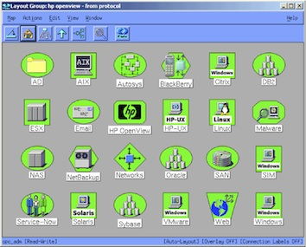**HP open view**

HP open view is a software that is used by companies that can manage the IT infrastructure. It does all sorts of activities to help the computer e.g. detecting malware, alerting, managing devices and applications. ‘HP’ comes from the HP family. It may confuse some people, but the job it does it helps others. As the image shows, they are a number of buttons to choose what the company/user needs help on. This is a top-level HP overview.

**Cisco works**

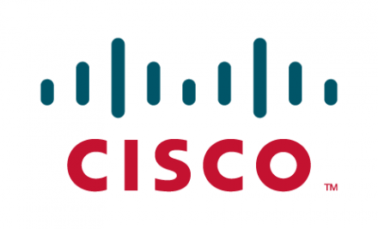This American company works its way round and designs, manufactures and sells managing network equipment. Each ‘cisco’ has its own equipment to deal with and today, cisco works deals with routers. Cisco works has an LAN management solution that is a web-based suite of tools developed in java by Cisco Systems. The main purpose of using this works is to use the anti-virus that is installed on the system to block any intruders entering the network. This is important, as many people will try to enter the network. This will to stop any person trying it.

**Wire shark**

The purpose of Wireshark is a software that is used for network troubleshooting, analysis of the network and the communicating of the protocol. This is a network protocol that is used by companies. Wire shark will act like an anti-virus and if any nothing that Wireshark thinks it is appropriate for the computer, it will detect and remove it. Therefore, it acts like a protector but does the job of a network as well. Originally, the name was Ethereal, but in 2006, they renamed it. Wireshark has a number of features to display its network features. Any user can browse this program and download it of its original page.

**HP open view**

The purpose of HP openview is to allow technicians or users to manage applications, device availability, network conditions and status, service and program maintenance, storage resources and the systems performance so that they can keep track of what is happening in their network. Also HP openview is used in organisation to maintain their computer systems and to make sure it does to get hacked and also to keep the information/data safe.

